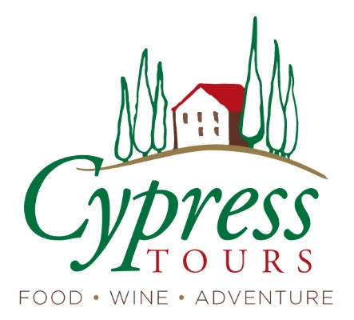

A Taste of Italy and France

Day 1 Depart U.S.
(time) Depart U.S. for Turin, Italy

Turin, Italy
Hotel dei Pittori
(4 nights)

Day 2 Arrive Turin
~2:00 Airport transfer
4:00 two-hour walking tour of the historic center, including a look at the Mole Antonelliana which houses the international Museum of Cinema (you might want to come back to go inside!)
7:00 Welcome reception and dinner in the atrium
- Includes: hotel, dinner, reception, driver

Day 3 Piedmont countryside
Breakfast
9:00 driver picks up for visit to La Morra for spectacular views and to Grinzane Cavour Castle, with a visit inside (especially the Sala delle Maschere where the Alba white truffle auction is held every year)
13:00 go to Barolo winery for cellar tour and tasting lunch
4:00 return to Turin; evening at leisure
- Includes breakfast, winery tour and tasting lunch, castle entry, hotel

Day 4 Let’s Cook!
Breakfast
9:30: Private transfer to cooking lesson
with a local chef, to learn some traditional dishes – and then enjoy the fruits of our labor - lunch as prepared by the group
~3:30 evening at leisure; driver takes group back to hotel and/or drop in town center
- Includes: breakfast, cooking lesson/lunch, hotel

Day 5 Tasting Turin
Breakfast
Day at leisure (museums, galleries, monuments, shopping, or put your feet up) So many things to see and do here!
3:30 we’ll stroll through town on a Taste of Turin food tour.
We will stop in several iconic places to try the local fare, including a typical Vermouth cocktail (this is the birthplace), a chocolate shop, and the huge indoor market/food court to enjoy their local “plin” pasta.
- Includes: breakfast, food tour/dinner, hotel

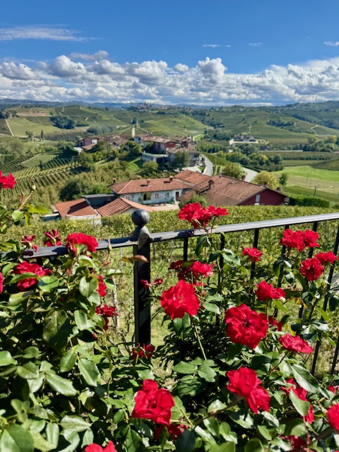

Bayeux, France
Hotel Reine Mathilde
(4 nights)

Day 6 Transfer to Paris, Bayeux
*Long travel day, but very scenic
6:30 Driver picks up at Hotel Pittori for transfer to train station.
~ 7:11 take the direct train from Turin to Paris - 6 hours, through the Alps and the French countryside
Take lunch on train or get something from the restaurant car
Meet our private driver and transfer to a different train station
~3:00 train to Bayeux (2.5 hours through Normandy) Arrive at hotel, get settled.
7:30 dinner at hotel
- Includes: breakfast, 1st class train tickets, private drivers, dinner, hotel

Day 7 Pays d’Auge
Breakfast
10:00 walking tour of Bayeux to learn more about this charming village
12:00 private driver-guide will take us through the gorgeous green Normandy countryside for a traditional lunch experience. We will learn of a local family's history and gain a full appreciation of Normandy's most cherished natural resource: the apple. And we’ll experience these gastronomic highlights: cider and calvados, brandy, during our tour and lunch at a family-owned cidery
4:00 return to Bayeux; evening at leisure
- Includes: private driver, walking tour, cider visit tour and lunch, hotel

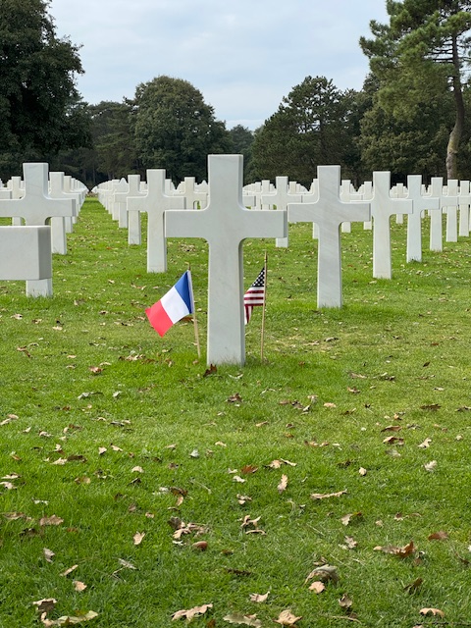

Day 8 Normandy
Breakfast
9:30 private driver and guide to Normandy beach area; Omaha Beach, the Overlord Museum and the Normandy American Cemetery; stop for hosted lunch together
5:30 Return to Bayeux, evening at leisure
- Includes: private driver and guided visit to WWII monuments, lunch, hotel

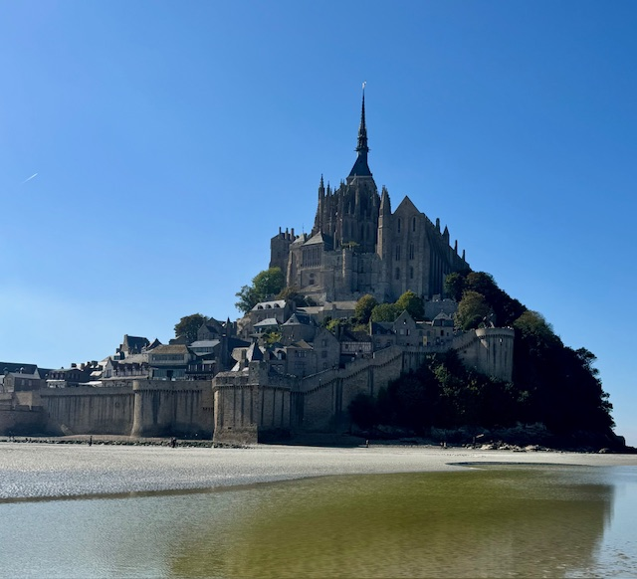

Day 9 Mont-Sant-Michel
Breakfast
8:00 our private driver and guide will take us for an in-depth visit to the monastery/castle of Mont-Sant-Michel
~10:30 comfort stop en route for coffee, early lunch, buy snacks for the day.
We’ll have the rare opportunity to walk in the bay at low tide and learn more about the 1,000-year history of pilgrimages to this unique place.
4:00 return to Bayeux for dinner
- Includes: private driver, guided visit and entry to Mont Sant Michel Abbey, dinner, hotel

Paris
Paris Art Hotel Quartier Latin
(3 nights)

Day 10 Transfer to Paris
Breakfast, check out
9:30 depart with private driver to Paris; stop in Giverny
12:00 arrive at the gardens and home of Claude Monet in Giverny. We’ll have entrance to his home, see his painting studio and the incredible gardens he brought to life. Free time for lunch with several options in the area.
3:00 depart for Paris
Arrive at hotel, get settled
7:30 dinner
- Includes: breakfast, private driver, Monet’s gardens, dinner, hotel

Day 11 Tasting Paris
Breakfast
10:00 depart for walking food tour/lunch in the timeless Marias district: “A historic, village-like area with narrow medieval streets, 17th-century mansions, independent boutiques, and a lively café culture — all wrapped in a creative, cosmopolitan energy. It’s one of the few Paris neighborhoods where you can feel the city’s past and present at the same time.”
1:00 afternoon at leisure
6:00 transfer to theater, or meet there at 6:30
Théâtre des Nouveautés, 24 Boulevard Poissonnière
7:00 comedy show “How to be a Parisian in One Hour”
8:15 return to hotel
- Includes: breakfast, food tour/lunch, private driver, theater tickets, hotel

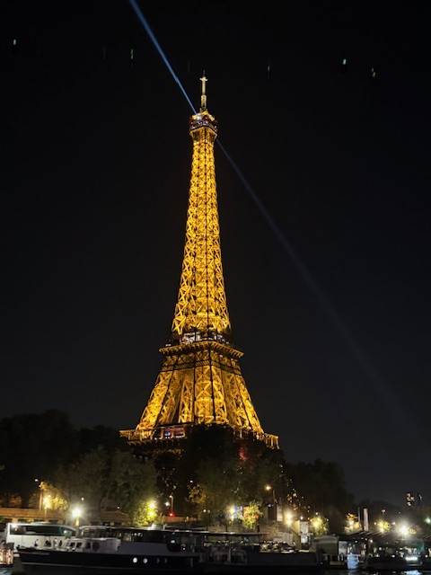

Day 12 Paris glam
Breakfast; morning at leisure
11:30 Driver picks up for transfer to Eiffel Tower.
12:00 gourmet lunch at a glass-walled restaurant with view of the Tower
3:00 free time in the area to explore independently (book an entry to go up the tower; tour the Louvre, Musee d’Orsay, Tuileries Garden.)
(Paytons and Plank leave on train to Frankfurt)
6:45 meet at Pont de Neuf for ~7:15 sunset boat tour along the Seine; watch the Eiffel Tower and monuments light up.
Evening at leisure
- Includes: breakfast, private driver, lunch, boat tour with drinks/snacks, hotel

Day 13 Au revoir, Paris!
Breakfast, check out
7:00 transfer to airport
11:20 Whitcomb flight;
- Includes: breakfast, private driver

