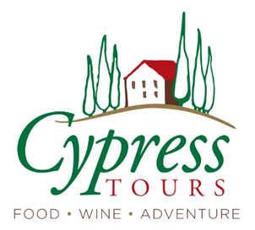

A Taste of the Basque Country

Day 0 Overnight flight
Depart U.S. for Bilbao
San Sebastian
(4 nights)

Day 1 Tour begins - San Sebastian
Mid-day - Arrive in Bilbao Airport (BIO) with a transfer (1-hour drive) to San Sebastian. Check into hotel and get settled
Afternoon: Stroll along the beach and the scenic promenade. Visit the Peine del Viento sculptures by Eduardo Chillida at the western end of the bay.
5:00 Orientation walk through the area
6:00 welcome reception and dinner
- Includes: private transfer, reception, dinner, hotel

Day 2 Cruising the city
9:00 walking tour with our guide Ainhoa who will walk us through “San Seb” old town to see the highlights of her city
12:00 free time for lunch, exploring
4:00 depart for the marina and enjoy a sunset cruise along the coast, dinner and beverages on board.
- Includes: breakfast, walking historic tour, sunset boat tour/dinner, hotel

Day 3 Basque Coast, Getaria
Breakfast
9:30 We will make the scenic drive to a txakoli vineyard (the local white wine) nestled in the picturesque green hills overlooking the Bay of Biscay. This boutique winery has been in the same family for 3 generations and offers a very local “off the beaten path” experience.
We’ll visit village of Zumaia, with its famous rock formations.
1:00 stop in the seaside village of Getaria for free time and an amazing seafood lunch cooked over a charcoal grill.
Evening at leisure
- Includes: breakfast, private driver-guide, wine-tasting, lunch, hotel

Day 4 Hondarribia + Cider
breakfast
9:00 we’ll depart for a day trip with our driver/guide to Hondarribia and to St. Jean de Luz in the French Basque country. We’ll stop at a sideria in Hondarribia for a tour and tasting lunch (30-minute drive). Free time to explore the colorful fishermen’s quarter and medieval walled town.
5:00 return to hotel, evening at leisure
- Includes: breakfast, transfer, historic villages, lunch and cider, hotel
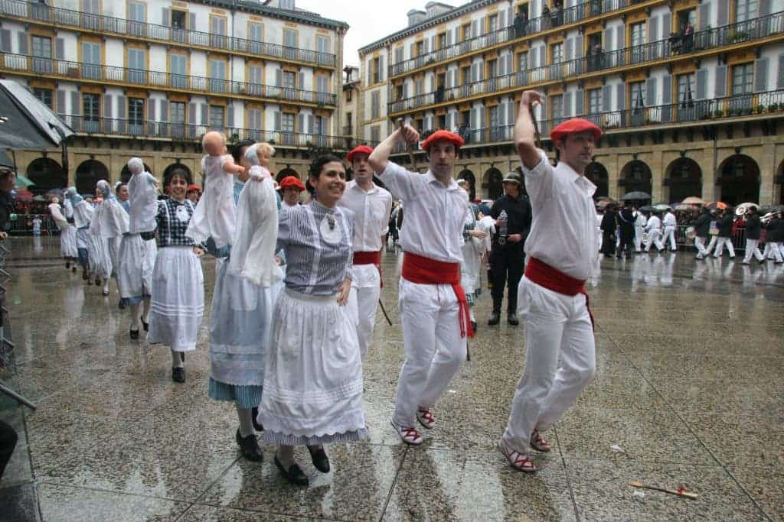

Bilbao
(5 nights)

Day 5 move to Bilbao
Breakfast
8:30 depart with driver to visit the La Rioja wine region, taste its quality wines and enjoy the stunning landscape
~10:30 We will first visit a family-owned boutique winery in a century’s old village. We’ll visit the cellars and then go for a tasting of 3 distinct wines. Then we’ll move on for lunch…and more wine!
~1:00 we’ll visit another family winery where we’ll discover the winemaking process from vine to glass. Afterward, we’ll sit down to a delicious multi-course lunch at the winery, complete with perfectly paired wines.
~5:30 arrive at hotel and get settled
7:30 dinner
- Includes: breakfast, transfer to Bilbao, two winery visits, wine-tasting lunch, dinner, hotel

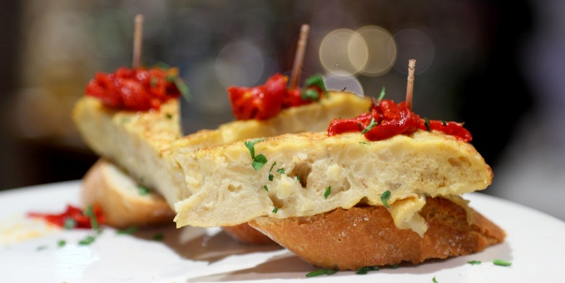

Day 6 Touring and Tasting Bilbao
Breakfast
9:45 private walking tour in Bilbao including a guided visit the striking Gugenheim Modert Art Museum. Our guide will also take us through Old Town and the Ribera Market – the largest covered market in Europe! A great cultural experience when visiting the city.
~1:00 free time for lunch, exploring, shopping
6:00 depart for another can’t-miss cultural experience – a Bilbao Pintxo tour! We’ll visit 5 bars, taste 8 pintxos and 5 beverages. After the Bilbao food tour, you will know all the best bars of the city and how to order on your own!
9:00 return to hotel
- Includes: breakfast, private walking tour, Gugenheim entry, food tour/dinner, hotel

Day 7 Basque Cooking!
Breakfast
11:00 depart for cooking lesson at the highly rated local favorite, Gastronimia Bilbao.
2:30 return to hotel; evening, dinner at leisure
- Includes: breakfast, cooking lesson/ lunch, hotel

Day 8 Wine and Gernika
Breakfast
9:00 We will depart to visit the historic village of Gernika. This city holds immense political importance for the Basque people. Local politicians have made important national decisions here for nearly 1000 years. Gernika also has historical significance as the sight of a horrific aerial bombing in 1937. This day in history was the inspiration for Pablo Picasso’s famous Guernica painting, which portrays this infamous day.
Our next stop will be the beautiful island of San Juan de Gaztelugatxe. This unique island sits just off the Basque coastline along the Bay of Biscay and is connected to the mainland by a man-made stone bridge.
After Gaztelugatxe, we will make our way to a beautiful Txakoli (Basque white wine) winery in the hills of Bizkaia. These wineries cover the hills there, creating a dramatic scene against the ocean. We’ll taste three wines with a light lunch.
4:00 return to hotel
Evening at leisure
- Includes: breakfast, private driver and guide for the day, winery visit and lunch, hotel

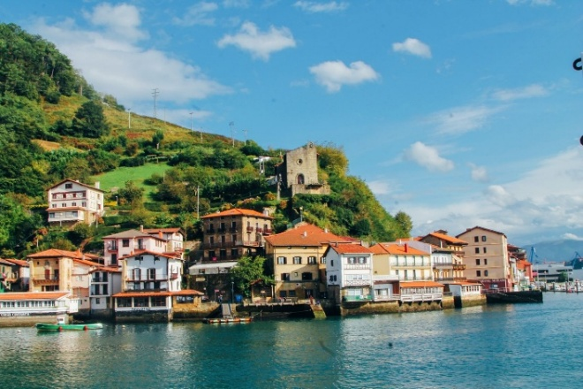

Day 9 Pick your pleasure
Breakfast
Day at leisure to take in your own must-see visits (ideas below)
7:30 farewell dinner
- Includes: breakfast, dinner, hotel

Day 10 Agur Euzkadi!
Breakfast
Time TBD – transfer to Bilbao airport or train station
- Includes: breakfast, airport transfer

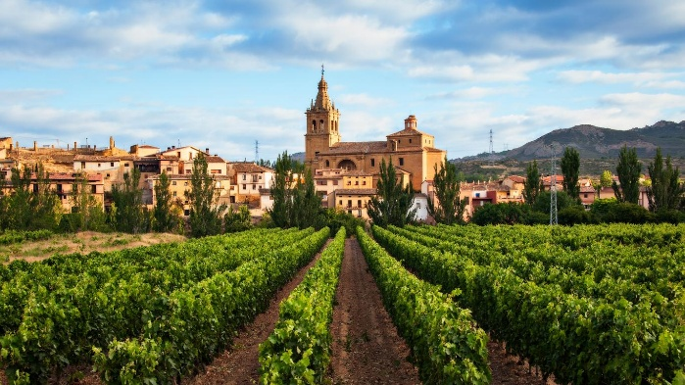

Tour Inclusions:
- 9 nights hotel accommodation
- 4 private guided tours: San Sebastian, Gernika, Hondarribia, Bilbao
- Admission to Gugenheim Museum
- Private drivers and airport transfers
- 3 winery tours and tastings
- Private sunset boat cruise along San Sebastian coast
- Private cooking lesson
- Private food and culture walking tour
- Cider tasting
- Breakfast every day
- Lunches and dinners as noted, wine included
- Tips to guides, drivers and restaurant servers

Exclusions:
- Airfare
- Tips to hotel staff (concierge or housekeeping)
- Transportation outside the stated schedule
- Travel insurance
- Additional wine or alcoholic beverages beyond what is provided with each meal

Special note:
- Language: Basque and Spanish are widely spoken. English is common in tourist areas. Trying out some basic Basque phrases is fun: “Kaixo” (kye SHOW; hello), “Eskerrik asko” (es care eek AHS ko; thank you) or “Agur” (ah GOOR; goodbye).

Options during free time:

Bilbao
- Visit Vizcaya Bridge (20-minute metro ride to Portugalete), a UNESCO World Heritage Site. Cross the bridge via its gondola or walk the upper walkway for views.
- Explore the Bilbao Fine Arts Museum, home to works by Goya, El Greco, and Basque artists.

San Sebastian
- Take the funicular to Monte Igueldo for panoramic views of the city and coastline
- Visit San Vicente Church and the Basilica of Santa María del Coro.
- San Telmo Museum or Buen Pastor Cathedral.

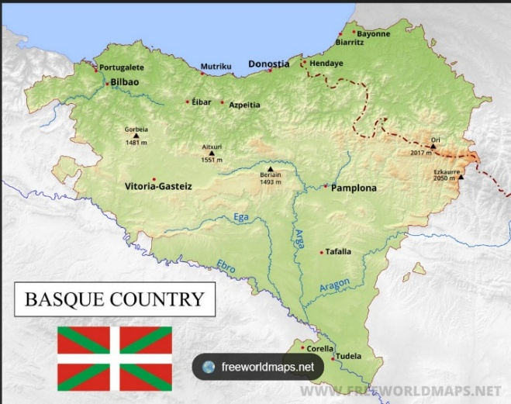

Map of our travels:

