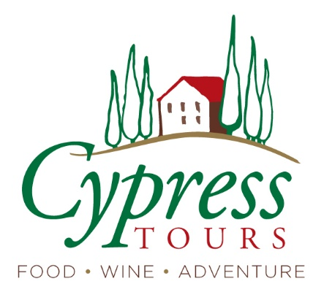

A Taste of Paris and The French Dordogne:
Glamour, Castles and Wine

Day 1: Overnight Flight
Depart U.S. for France (arrive in Bordeaux by air or train via Paris)

Paris
Paris Art Hotel
Dates (4 nights)

Day 2: tour begins - Paris
(time TBD) pick up at Paris Airport (CDG), transfer to hotel
Arrive at Paris Art Hotel, rest, get settled, explore the neighborhood
6:30 welcome reception
7:00 dinner
- Includes: private airport transfer, reception, dinner, hotel

Day 3: Paris food tour and fun
breakfast
10:00 depart for walking food tour/lunch in the historic Marais district
1:00 afternoon at leisure
6:00 transfer to theater
7:00 comedy show “How to be a Parisian in One Hour”
8:30 driver picks up for return to hotel or drop off for dinner along the way
- Includes: breakfast, food tour, private driver, theater tickets, hotel

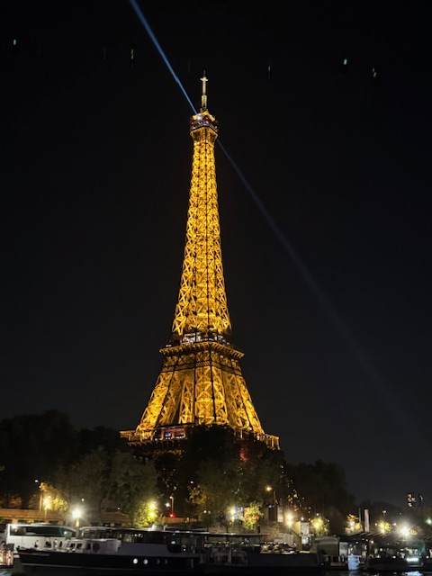

Day 4: Historic Paris + boat tour
Breakfast; morning at leisure
9:30 Driver picks up for transfer to Eiffel Tower. Visit the tower’s observation deck on the second level.
12:00 gourmet lunch at a glass-walled restaurant with view of the Tower
3:00 free time in the area to explore independently (book an entry to go to the top of the tower; tour the Louvre, Musee d’Orsay, Tuileries Garden.)
6:45 meet at Pont de Neuf for ~7:15 sunset boat tour along the Seine; watch the Eiffel Tower and monuments light up.
Evening at leisure
- Includes: breakfast, private driver, lunch, boat tour with drinks/snacks, hotel

Day 5: Paris – the Louvre
Breakfast
10:00 We will meet our guide at the Louvre for a private tour of museum highlights and history.
Afterward, enjoy free time for lunch and these ideas:
Consider taking the metro or cabbing to the Montmarte area for spectacular views of the city from Sacre Coeur Basilica (free to visit; open 6:00 a.m. to 10:45 p.m.) You can also climb the dome for even better views – 300 steps. Access to the dome is outside the basilica on the left. Paid entry; 10:30 am to 8:30 p.m.)
Walk by the Moulin Rouge (or book a show)
Restaurant recs from locals in Montmarte area
7:30 meet back at the hotel for dinner nearby
- Includes: private guided tour, entry to Louvre, dinner, hotel

Vezac, Dordogne River
Manoir de la Malartrie
Dates (6 nights)
Between the castles of Marqueyssac, Castelnaud and Beynac.

Day 6: Bordeaux and Dordogne
Breakfast, check out

9:30 take the highspeed train south to Bordeaux (bring snacks or a picnic for the ride)

2:00 transfer to the famous City of Wine museum, Cité du Vin for a tour
4:30 continue our journey along the scenic vineyard-lined Dordogne River to the Manor of Malartrie
7:30 dinner
- Includes: breakfast, private driver, admission to museum and tour, dinner, hotel

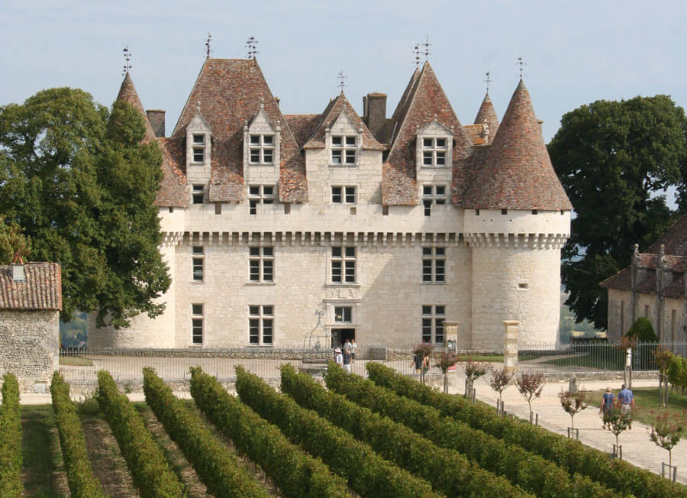

Day 7: Dordogne, Périgord noir
Breakfast
9:00 depart for Sarlat-la-Canéda
10:30 stop at Château de Monbazillac for castle tour and wine tasting
12:30 depart for lunch in Bergerac
3:00 depart for Sarlat-la-Canéda (Vezac)
5:30 return to manor for an evening at leisure

- Includes: breakfast, castle visit and wine tasting, lunch, hotel

Day 8: Sarlat-la-Canéda medieval village, Foie Gras Farm
breakfast
9:00 depart for private walking tour of Sarlat; free time for lunch in the village
1:30 depart for Foie Gras farm for tour
4:00 return to manor/hotel
7:30 dinner
- Includes: breakfast, private driver, guided tours, dinner, hotel

Day 9: Dordogne cooking class, historical sites
breakfast

9:00 depart for Le Chevrefeuille for cooking experience

10:00 cooking school, prepare regional lunch together
2:00 depart for Fort a scenic river boat tour
6:00 return to the manor; evening, dinner at leisure
- Includes: breakfast, private driver, cooking school, lunch, private boat tour on Dordogne River

Day 10: Paleolithic cave, castle and walnuts
breakfast
9:00 depart for Montignac
9:30 Private tour of Lascaux International Center of Parietal Art
12:00 lunch at leisure near the center or a short walk into town
1:30 depart for Château de Castelnaud
2:00 tour the castle
4:00 depart for the Walnut Ecomuseum, at the foot of the castle
5:30 attend the “pressing of the oil”
6:30 dinner at in the Courtyard of the Mill
8:30 Return to the manor/hotel
- Includes: breakfast, private driver, guided tours, lunch, dinner, hotel

Day 11: Farmer’s Market, castles
breakfast
9:00 depart for Sarlat farmer’s market (also, gourmet tour and tastings available)
Shopping and lunch at leisure
2:30 depart for Château de Beynac and castle tour
5:00 depart for Marqueyssac castle and gardens for tour and farewell dinner
- Includes: breakfast, private driver, guided tours, dinner, hotel

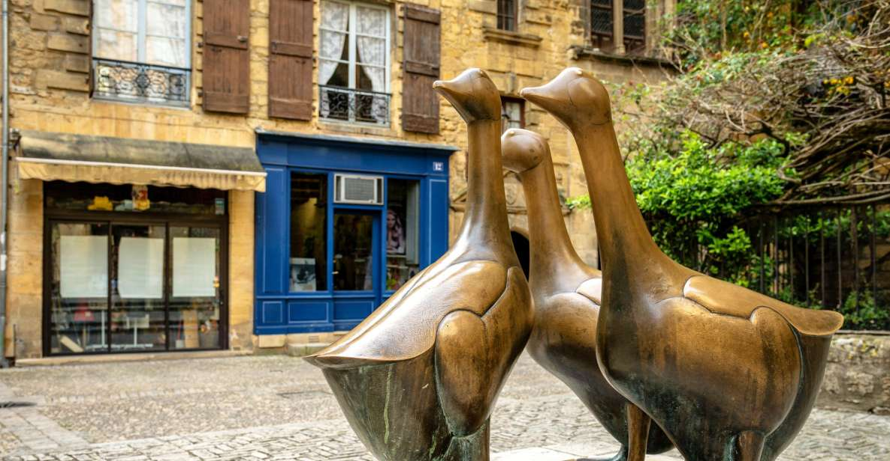

Day 12: tour concludes
breakfast
(time TBD) depart manor/hotel for transfer to Bordeaux Airport (BOD)
- Includes: breakfast, private driver

Tour Inclusions:
- 4 nights, Paris
- 6 nights, Sarlat-la-Canéda
- 3 private guided tours: Paris, Saint-Émilion, Sarlat-la-Canéda, foie gras farm, walnut oil pressing, a historic fort and world-famous Paleolithic cave
- 3 winery tours/tastings and wine museum tour with immersive tasting
- Boat tour on Dordogne River
- 4 castle tours
- Private drivers and transfers
- 1 private cooking lesson
- Breakfast every day
- Lunch and dinners as noted, wine hosted
- Tips to guides, drivers and restaurant servers

Exclusions:
- Airfare
- Tips to hotel staff (concierge, housekeeping)
- Transportation outside the stated schedule
- Travel insurance
- Additional wine or alcoholic beverages beyond what is provided with each meal

Things to do in Paris:
- check out the Arc de Triomphe
- visit sights downtown like the Paris catacombs (purchase online in advance), walk by the Bastille memorial, walk around Notre Dame or get timed-entry tickets to go inside
- check out a free walking tour

