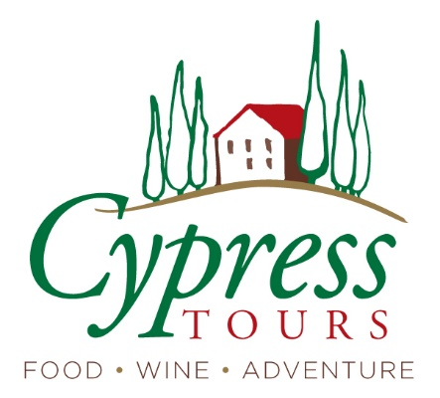

North Italy Gems:
Lake Como and the Alps
June 7-17, 2023

*times are approximate and may adjust daily*

Day 1 Wed, June 7
Depart U.S. for Geneva Switzerland (Or depart a day or two earlier and explore.)

June 8-13 (5 nights) Hotel/Spa Milleluci
Aosta
Day 2 Thurs, June 8 Arrive in Aosta
2:00 pick up at Suisse Hotel in Geneva; drive through the Alps, crossing Switzerland, France and Italy, including the famous 7-mile Mont Blanc tunnel
4:00 arrive in Aosta, get settled and check in to hotel/spa
6:30 welcome reception
7:00 dinner up the hill
- Includes: private airport transfer, reception, dinner, hotel

Day 3 Fri, June 9 Aosta
breakfast
10:00 private walking tour in town with Elisabetta; end with cheese and salami tasting
Afternoon at leisure: explore, shop
Spa time at the hotel
7:30 dinner
- Includes: breakfast, private transfer to dinner, private walking tour, dinner, hotel

Day 4 Sat, June 10 Up to the Alps
breakfast
10:00 drive back up the valley to the Monte Bianco Skyway
11:00 take the Skyway to the top, traditional alpine lunch, endless photo opps
3:00 go back down to Courmayeur to walk through historic center
5:00 return to hotel, evening at leisure
- Includes: breakfast, private transfer, Monte Bianco Skyway experience, lunch, hotel

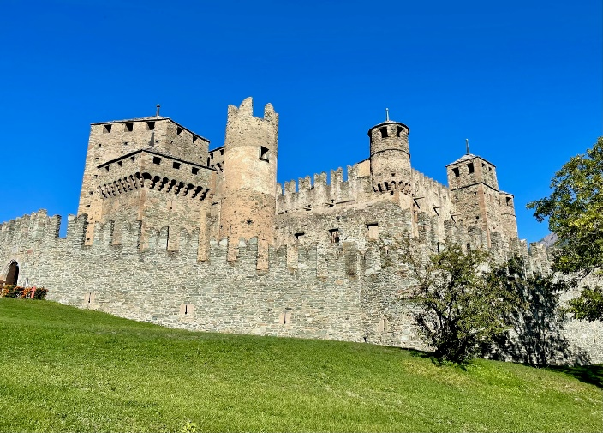

Day 5 Sun, June 11
breakfast
9:00 depart for Fenis Castle, 9:30 tour
10:00 depart with Elisabetta for high valley area
lunch stop along the way; visit cheese producer
5:30 return to hotel, afternoon at leisure; spa, shop
Evening at leisure
- Includes: breakfast, private driver, entry to castle with tour, dinner, hotel

Day 6 Mon, June 12
breakfast
morning at leisure, spa, shop
2:00 drive to Les Cretes for winery tour/tasting
4:00 cooking lesson of traditional recipes with Franca in her home
- Includes: breakfast, winery visit, cooking lesson/dinner, hotel

June 13-17 (4 nights)
Hotel Del Duca
Como

Day 7 Tues, June 13 Aosta - Como
breakfast
9:30 lower valley tour with Elisabetta; depart for Gressoney and Castel Savoia
1:00 lunch break, continue on to Como
4:30 walking tour of the expansive mostly-pedestrian historic center
7:00 walk to dinner nearby
- Includes: breakfast, driver, tours of castle, Como, dinner, hotel

Day 7 Wed, June 14
breakfast
10:00 depart for eBike tour (“pedal-assist” bikes that you can adjust for ease of pedaling) We’ll travel through villages, past villas, through vineyards and cross into Switzerland
1:00 lunch on the lake
3:30 evening, dinner at leisure
- Includes: breakfast, private e-bike tour and lunch, hotel

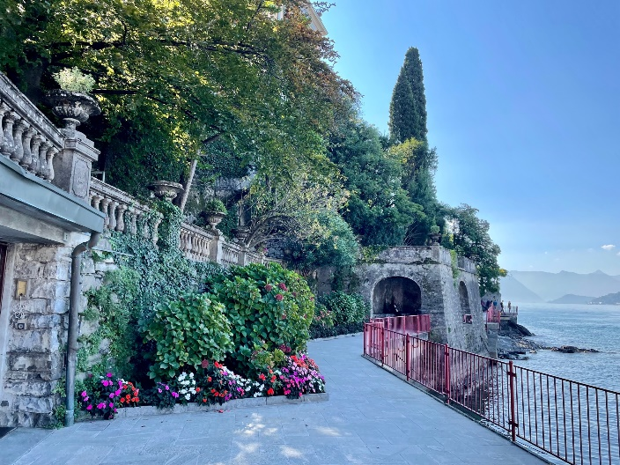

Day 8 Thurs, June 15
breakfast
9:00 depart for Milan
10:00 private walking tour to see the duomo, the famous “Galleria Vittorio Emanuele II” shopping arcade
12:00 free time to have lunch, explore
3:00 visit Santa Maria delle Grazie church and museum for Da Vinci’s “Last Supper” painting
5:00 return to Como
7:30 dinner
- Includes: breakfast, private driver and tour in Milan, entry to Last Supper, dinner, hotel

Day 9 Fri, June 16
Breakfast; morning at leisure
11:00 private boat tour on Lake Como; stop at Villa Balbianello and village of Varenna to have lunch, explore, shop
5:30 return to Como
7:00 farewell dinner
- Includes: breakfast, private boat for lake tour, dinner, hotel

Day 11 Sat, June 17
Breakfast
9:00 depart hotel for Milan airport (MPX) or Hotel Villa Malpensa to stay the night near the airport

Tour price:
TBD per person, double occupancy
TBD per person, single occupancy
$500 deposit due at booking
Balance due March 3, 2023

Tour Inclusions:
- 5 nights, Aosta
- 4 nights, Como
- 3 private guided tours: Aosta, Como, Milan
- 2 winery tours and tastings
- 1 cheese tour and tasting
- Private boat tour on Lake Como
- Private drivers and airport transfer
- Breakfast every day
- 5 lunches (with wine)
- 6 dinners (with wine)
- Tips to guides, drivers and restaurant servers

Exclusions:
- Airfare
- Tips to hotel staff (concierge, housekeeping)
- Transportation outside the stated schedule
- Travel insurance
- Additional wine or alcoholic beverages beyond what is provided with each meal

Special notes:

Culture: Italy is beautiful, rich in history and culture – and fairly unpredictable. Italians are lovely, generous people, but they don’t necessarily run the “tight ship” we’re used to. I will manage everything I can, and I expect that everything is set. But things do happen after a plan has been made! I encourage flexibility – and being open to the magic of serendipity. You will likely hear this more than once during your trip: “It’s all part of the adventure!”

Activity level: this itinerary has a moderate activity level. There is walking each day, some hilly terrain, and a bike ride. I average about 5 miles walking per day. But when you’re surrounded by beautiful scenery and rich history, you don’t necessarily notice. There are ride options available (taxi, Uber, metro, bus) per your preference.

